**PIZZA SALES SQL QUERIES**

1. **KPI’S**
2. **Total Revenue**

select sum(total_price) as Total_Revenue from pizza_sales

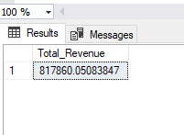

1. **Average Order Vales**

select sum(total_price)/ count(distinct order_id) as Average_Order_Value from pizza_sales

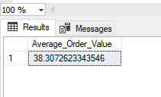

1. **Total Pizza Sold**

select sum(quantity) as Total_Pizza_sold from pizza_sales

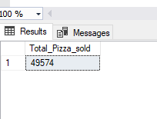

1. **Total Order**

select count(distinct order_id) Total_orders from pizza_sales

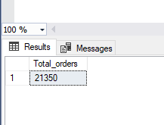

1. **Average pizza Sold**

select cast(cast(sum(quantity) as decimal(10,2)) /cast(count(distinct order_id) as decimal(10,2)) as decimal(10,2)) as Averae_pizzas_by_order from pizza_sales

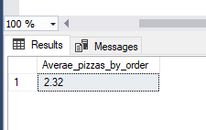

1. **Daily Trend Total Order**

select DATENAME(DW, order_date) as day_order, count(distinct order_id) as Total_order

from pizza_sales

group by DATENAME(DW, order_date)

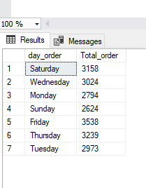

1. **Hour Trend for Total Orders**

select DATEPART(HOUR, order_time) as hour_order, count(distinct order_id) as Total_order

from pizza_sales

group by DATEPART(HOUR, order_time)

order by DATEPART (HOUR, order_time)

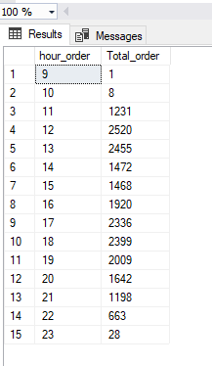

1. **PERCENTAGE SALES BY PIZZA CATEGORY**

select pizza_category, sum(total_price) as Total_Revenue,

cast(sum(total_price) * 100 / (select sum(total_Price) from pizza_sales) as decimal(10,2)) as Percentage_Sales

from pizza_sales

group by pizza_category

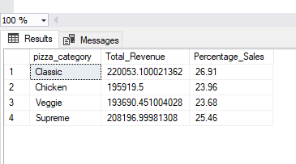

1. **PERCENTAGE SALES BY PIZZA SIZE**

select pizza_size, sum(total_price) as Total_Revenue,

cast(sum(total_price) * 100 / (select sum(total_price) from pizza_sales) as decimal(10,2)) as PCT_Pizza_size

from pizza_sales

group by pizza_size

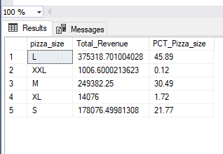

1. **TOTAL QUANTITY SOLD BT PIZZA CATEGORY**

select pizza_category, sum(quantity)as pizza_sold from pizza_sales

group by pizza_category

order by pizza_sold desc

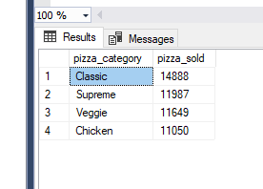

1. **TOP 5 BEST SELLER PIZZA SOLD**

select TOP 5 pizza_name_id, sum(quantity) as Best_seller

from pizza_sales

group by pizza_name_id

order by Best_seller DESC

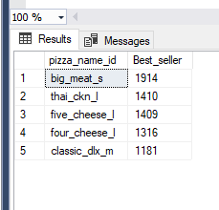

1. **TOP 5 WORST SELLER PIZZA SOLD**

select TOP 5 pizza_name_id, sum(quantity) as worst_seller

from pizza_sales

group by pizza_name_id

order by worst_seller ASC

